An End-to-End L-Band PolInSAR Architecture for Glacier Facies Segmentation and Temporal Mass Loss (∆SWE) Quantification using U-Net Deep Learning
Harsh Singhal (23BEC1021), Niket Suthar (23BEC1039), Suriya Dharsaun.C.K (23BEC1389), Naman Kamboj, and Vetrivelan Pandu
ABSTRACT
Swarm robotics require high bandwidth and low latency wireless communication that can be well coordinated. The current paper assesses the IEEE 802.11be (Wi-Fi 7) Multi-User Multi-Input Multi-Output (MU-MIMO) Multi-robot swarm performance in typical conditions like real-time communication networks or applications. We apply the WLAN Toolbox of MATLAB to simulate a 4x8 MU-MIMO downlink with the setting of maximum throughput (320 MHz bandwidth, MCS 13 using 4096-QAM) with difficult non-line-of-sight conditions (TGax Channel Model-D). Performance variables such as Bit Error Rate (BER) which is estimated by the throughput and Error Vector Magnitude (EVM) are examined at various Signal-to-Noise Ratios (SNRs). The outcomes of simulation show that although the system is capable of attaining the theoretically optimal supposed aggregate throughput of about 11.5 Gbps, consistent communications with MCS 13 in this fading channel necessitate high SNRs of (>40 dB). At 42 dB and above SNR the error-free performance is obtained, which underlines the advantage of the 8 antenna diversity gain of the receiver. The results indicate that although Wi-Fi 7 has a significant throughput potential of data-intensive swarm applications, it is not possible to support real-world deployments based on the top-level MCS modes due to range or the need to use link adaptation methods to achieve reliability.

Keywords: Swarm Robotics, Wireless Communication, Wi-Fi 7, IEEE 802.11be, MU-MIMO, Physical Layer Simulation, BER, Throughput, Channel Model-D.

1 INTRODUCTION
The rapid degradation of the global cryosphere serves as one of the most critical indicators of accelerated climate change. Accurate, continuous monitoring of glacier facies—including dry snow accumulation, meltwater pooling, and structural crevassing—is essential for modeling hydro-climatic dynamics and predicting global sea-level rise. Historically, remote sensing of these regions has relied heavily on optical satellite imagery. However, optical sensors are severely limited by ubiquitous cloud cover and prolonged periods of polar night, resulting in significant data gaps during critical transition seasons.
Synthetic Aperture Radar (SAR) provides a robust alternative, capable of acquiring high-resolution data independent of solar illumination or weather conditions. Specifically, L-band SAR, such as the Advanced Land Observing Satellite (ALOS) PALSAR, is highly advantageous for glaciology. Its relatively long wavelength (approx. 24 cm) allows the radar signal to physically penetrate the dry snowpack and interact with the subsurface glacial topography. By applying Polarimetric Interferometry (PolInSAR) and inverting physical scattering models like the Random Volume over Ground (RVoG) model, it is possible to mathematically extract the 3D penetration depth of the snow layer.
Despite these physical advantages, traditional SAR processing pipelines remain computationally expensive and difficult to scale across massive, multi-temporal datasets. Furthermore, while modern Deep Learning techniques have revolutionized optical image classification, their application to complex, phase-preserving radar data remains an active challenge due to the lack of ground-truth labels and the presence of radar speckle noise.
To address these limitations, this study proposes a novel, end-to-end computational architecture that fuses pure radar physics with advanced spatial deep learning. Utilizing ALOS PALSAR Level 1.1 Single Look Complex (SLC) data, this pipeline autonomously transitions from raw binary signal ingestion to climate-level quantification.
The primary contributions of this methodology are threefold:
- Physical Feature Extraction: The automated generation of covariance matrices and Dual-Pol Pseudo-Pauli composites to physically isolate structural scattering mechanisms.
- Multi-Temporal Mass Loss Quantification: The mathematical co-registration of winter and summer radar epochs to calculate absolute temporal mass loss, yielding high-resolution Change in Snow Water Equivalent (∆SWE) maps.
- Self-Supervised Spatial Segmentation: The deployment of a medical-grade U-Net Convolutional Neural Network architecture. By utilizing physical thresholds as dynamic pseudo-labels, the U-Net successfully learns the continuous spatial geometry of glacier facies without requiring external, human-annotated datasets.
By bridging the gap between rigorous tomographic radar physics and high-efficiency computer vision, this architecture presents a highly scalable framework for automated polar ice monitoring and temporal climate tracking.

Literature Survey
This part presents some previous research on the wireless aspect of communication in swarm robotics and the opportunities of new standards, such as, IEEE 802.11be (Wi-Fi 7).
It has been well-known that swarm robotics is highly dependent on communication that is highly effective [1]. The research shows the critical nature of high bandwidth, low latency, scalability, and reliability, in case of real-time applications of rich sensor data as in Swarm SLAM [2], [3]. The mobile network topology and the possibility of high-density deployments in swarms, however, represent a serious challenge to the conventional wireless protocols [4].
Older protocols that are often utilized in robotics are limited. Small power such as Zigbee (IEEE 802.15.4) is scalable, but has very low data rates (250 kbps), making it inappropriate in high-speed applications [5]. A slightly higher rate is offered by Bluetooth Classic (IEEE 802.15.1) but with a restriction of a limited size of the network (piconet structure) [5]. Although earlier standards of Wi-Fi (IEEE 802.11ac/ax) are high throughout, the power consumption, and contention-based medium access (CSMA/CA) may severely impact the performance in dense mobile ad-hoc swarm networks [6]. Even Wi-Fi 6 has been shown to be slowed down in an experimental study even in highly-dense and mobile situations [7].
Extremely High Throughput (EHT) features have been added to IEEE 802.11be (Wi-Fi 7) standard to potentially overcome these constraints [8]. Among the most important innovations, there is 320 MHz channel bandwidths contributing to an increased capacity, 4096-QAM modulation because of higher peak rates, and improved Multi-User MIMO (MU-MIMO) possibilities that permit the concurrent transmission to more than two users [8], [9]. These characteristics have a theoretical basis of high enhancement in throughput and spectral efficiency applicable to swarm communication requirements. Initial simulations and tests of Wi-Fi 7 have shown that improvements in throughput and latency are possible, making use of such features as Multi-Link Operation (MLO) [10], though the reality of the performance, especially in difficult NLOS ones, may vary greatly compared to the theoretical maximums and can be sensitive to factors such as distance and interference [11].
2.1 Issue Statements and Research Gap
Whereas the demands of communication of swarm robotics are defined by the existing literature along with the theoretical potential of Wi-Fi 7, there is a certain gap. Wi-Fi 7 most advanced features (particularly, 320 MHz bandwidth with 4096-QAM with MU-MIMO) executed directly over the swarm robotics coordination problem under realistic including challenging channel conditions (NLOS, modeled as TGax Model-D) have not been evaluated in any way. The existing literature presumes the swarm algorithms when perfect communication is assumed or considers the old operating protocols or experiments Wi-Fi 7 in a common static environment.

  - Objectives
This paper makes efforts to fill this gap through a specific physical layer simulation analysis. It is aimed at determining which Bit Error Rate (BER) and throughput can be achieved by a Wi-Fi 7 MU-MIMO downlink operating a four-robot swarm with MCS 13 on a Model-D channel. The findings will help obtain invaluable information on the practicality and performance limits of Wi-Fi 7 implementation in swarm robotics programs with high demands and in real-time.

Wi-Fi 7 based Transceiver for Real-time Swarm Robotics Coordination
This paper uses a simulation to assess the physical layer (PHY) of a Wi-Fi 7 Multi-User Multi-Input Multi-Output (MU-MIMO) multi-user system to support swarm robotics communication. MATLAB R2025A together with WLAN Toolbox was used to implement the simulation.

3.1 Simulation Scenario
The scenario represents a communication link over a single downlink and four robots in a swarm all controlled by a central one which may be a representative of a base drone or access point (AP). MU-MIMO transmission scheme is used, which allows simultaneous data rates in each robot using the time-frequency resources. The antenna design presumes 4 transmit antennas (NT = 4) at the central controller and 8 receive antennas (NR = 8) at each mobile robot which forms a 4 x 8 MU-MIMO structure. 3.2 Wi-Fi 7 PHY Configuration.
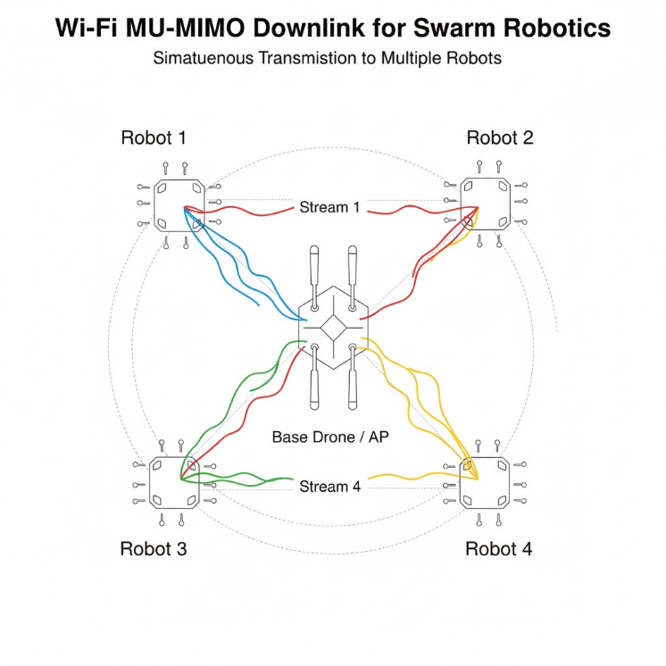 Fig. 2. Simulated 4x8 MU-MIMO downlink scenario: A 4-antenna base drone (AP) simultaneously transmits independent spatial streams (Stream 1-4) to four distinct 8-antenna robots.

3.2 Wi-Fi 7 PHY Configuration
The waveform that is being transmitted conforms to IEEE 802.11be (Wi-Fi 7) Extremely High Throughput (EHT) standard. The wlanEHTMUConfig object was used by configuring from important PHY parameters as below:
- Channel Bandwidth 320MHz (CBW320), makes use of the upper bandwidth in the standard.
- Modulation and Coding Scheme (MCS): MCS 13, which is 4096-QAM modulation and 5/6 Low-Density Parity-Check (LDPC) codes rate. This is the maximum data rate mode which exists.
- Spatial Streams: The 4 robots were assigned 1 spatial stream (NSS = 1). That is why the number of spatial streams which are conducted by the AP at the same time is 4.
- Payload Length (APEPLength): The size of the payload assigned to each robot was 100,000 bytes in each packet.
- Guard Interval: 0.8 us Guard Interval was employed.
A baseband waveform was produced by using the wlanWaveformGenerator function of which corresponding scrambling and LDPC encoding was implemented .
  - Channel Modeling
The TGax channel model was simulated by the wlanTGaxChannel object being configured to the radio propagation environment as specified by IEEE 802.11ax to the 802.11be environment.
- Delay Profile: Model-D has been chosen, which is a typical indoor Non-Line-of-Sight (NLOS) situation with severe multipath fading.
- Distance: The distance between the AP and each robot was adjusted to 10 meters.
- Sample Rate: The simulation was running at a baseband sample rate (F_{s}), but it was equal to the channel bandwidth.
The received signal was impaired by Additive White Gaussian Noise (AWGN), to replicate the change in Signal-to-Noise Ratio (SNR) conditions. The different SNR points were computed and the noise variance determined depending on the average transmitted signal power.
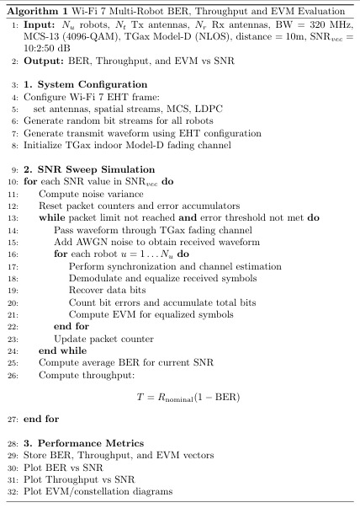
  - Pseudo Algorithm
  - Simulation Procedure
The Monte Carlo simulation method was used and the SNR values in 2 dB steps were run between 10 dB and 50 dB. Several independent packets were modeled on each SNR point to be statistically reliable.
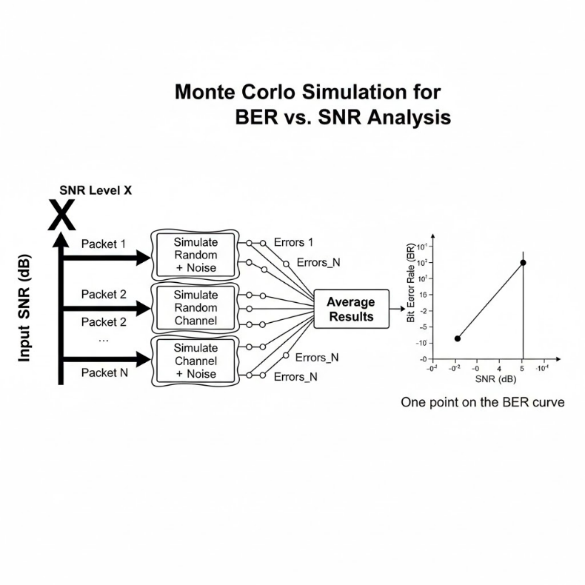
Fig. 3. Illustration of the Monte Carlo simulation procedure used to determine BER vs. SNR. Multiple independent packet simulations (N) incorporating random channel effects and noise are performed at each SNR level, and the resulting errors are averaged to obtain a statistically reliable BER estimate for that SNR point.
- Packet Transmission: The number of packets that were attached per SNR point was 50 maximum (numPacketsPerSNR).
- Termination Criteria: Early termination criteria had been incorporated to maximize the time spent in simulation. The process of simulation loop at a given SNR point left when either:
  - MinErrors is at least 1000-bit errors (minErrors) over all the users.
  - The number of bits that could be successfully decoded within 1 user was at least 10 million (1e7). The next SNR value was then taken when either of the two thresholds was reached or the maximum number of packets was attained and the simulation was aborted.
3.5 Performance Metrics
To measure performance of the system, the following metrics were computed:
- Bit Error Rate (BER): The BER is determined per user and (meaning divided by user), which is the ratio of the total amount of bit errors to the total amount of correctly decoded bits (sum of errors/sum of bits).
- Estimated Throughput: Compute by taking the nominal data rate of the user set MCS and bandwidth times the average value of BER, which has been determined (essentially the Packet Error Rate):

$$Throughput =Nominal Rate ×\left(1-\overline{BER}\right)$$
To fulfill MCS 13 (1SS, CBW320, 0.8us GI), the nominal rate is about 2.882 Gbps per stream.
- Error Vector Magnitude (EVM): Computed automatically as part of the comm.EVM System object within MATLAB and gives a value that is an indication of the quality of the received constellation in dB.

4. Discussions and Results of Simulation
The table below has provided the most important key performance measurements due to the MATLAB simulation of the Wi-Fi 7 MU-MIMO downlink scenario with MCS 13 to swarm robotics communication under extreme non-line-of-sight (NLOS) conditions (TGax Model-D). The findings measure the Bit Error Rate (BER), approximate throughput and Error Vector Magnitude (EVM) with respect to Signal to Noise Ratio (SNR) of this high-speed challenging setup.
SIMULATION SUMMARY TABLE (@ SNR = 50.0 dB)
------------------------------ Transmitter ------------------------------
Mode: MU-MIMO (Non-OFDMA)

Channel Bandwidth: CBW320 | Antennas (AP x Robot): 4 x 8
Sample Rate: 320 MHz | PAPR: 14.02 dB
Robots (Results @ 50.0 dB SNR - Averaged over 13 Packets)

Characteristic | Robot_1 | Robot_2 | Robot_3 | Robot_4
Payload (Bytes) | 100000 | 100000 | 100000 | 100000
BER | 0.0 | 0.0 | 0.0 | 0.0
Avg_EVM (dB) | -42.5 | -42.1 | -42.0 | -42.6
Est_Throughput (Gbps) | 2.882 | 2.882 | 2.882 | 2.882
Total_Est_Thr (Gbps) | 11.528

4.1 Bit Error Rate (BER) Performance
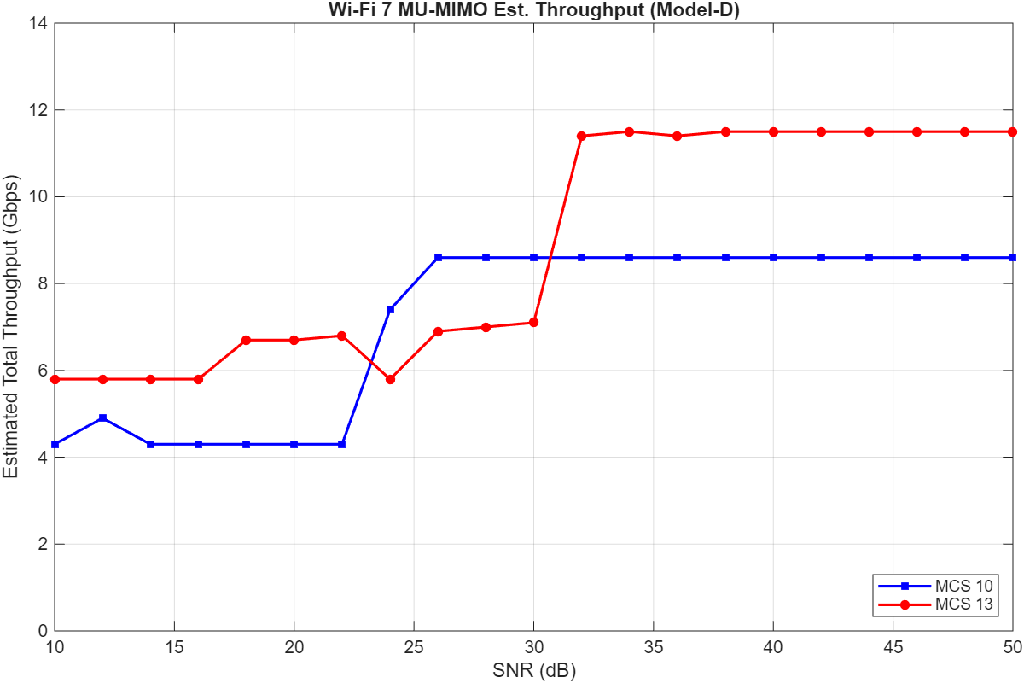
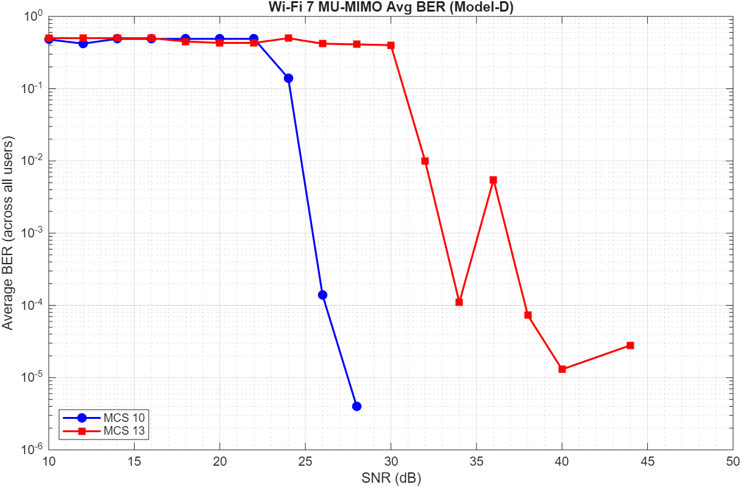
The mean BER of the four simulated robots as a function of SNR is shown in Fig. 4. The findings also demonstratively show how high-order MCS 13 (4096-QAM) modulation is sensitive to channels. The mean BER is stable and it is approximately 0.5 at lower SNR values (10 dB to about 30 dB) which is a sign of unreliable decoding. The individual waterfall region commences at approximately 32 dB, and the BER continues to increase rapidly as the SNR becomes greater. The BER automatically falls below 10-4 at 34 dB and the BER value continues to drop with increasing SNR values of 42 dB and more in the simulated number of packets. At a frequency of 44dB, a statistical anomaly leading to a somewhat higher BER is seen, which can probably be attributed to a random fluctuation of channels that occurred during that Monte Carlo run. The BER performance of each robot is presented in the main analysis diagram and has similar trends in waterfalls with minor differences because of independent channel realizations, in each use.
Fig. 4. Average Bit Error Rate (BER) across all four users as a function of SNR for the simulated Wi-Fi 7 MU-MIMO system (MCS 13, CBW320, Model-D).
The MCS 13 is highly sensitive as shown by the BER performance (Fig 4). It was not until SNRs were very high greater than 38 dB with reliable communication (BER < 10-4). The error-free performance occurred at SNRs greater than 42 dB. The link was practically unusable even below 32 dB (BER 0.5). The nature of the dense 4096-QAM constellation, in conjunction with the extreme amplification of multipath fading on the Model-D channel, is what makes such high SNR demand possible, as demonstrated in the channel frequency response plots (Fig 8). Both the EVM results (Fig 6) and the EVM results later support the required level of signal quality which only attains the desired threshold of -38 dB at around 38-40 dB SNR.
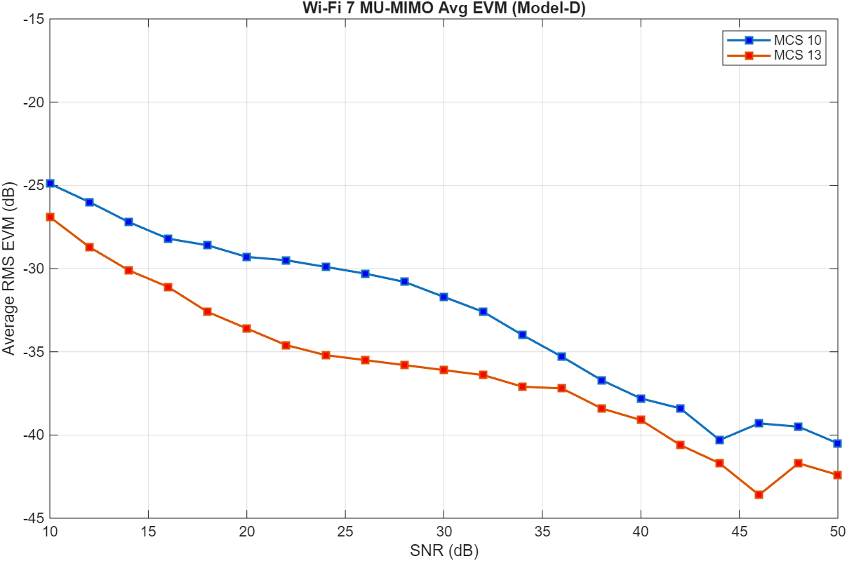
Though the system was able to reach its theoretical potential aggregate throughput of around 11.528 Gbps in a scenario with a high SNR (Fig 5), the high SNR requirement has a lot of implications in the real world. This can be difficult to maintain at such high SNR levels within a dynamic and mobile swarm and particularly in NLOS environments. It can also require shorter communication distances between the base station and the robots or possibly, entail a denser deployment through of communication infrastructure in the field of operation.
4.2 Estimated Throughput Performance
The aggregate throughput as a function of SNR is plotted in Fig 5 as an estimate. This indicator is a direct indicator of the BER performance. The throughput is estimated to be too close to zero in the low SNR region of less than 32 dB, where the BER is approximately 0.5. In line with the BER waterfall, the throughput is highly increasing between 32 dB and 42 dB. At a frequency above 42 dB, where the BER virtually becomes zero, the estimate of the total throughput is saturated at its maximum calculated nominal value of about 11.5 Gbps. This establishes that given enough SNR conditions, the system operates at the theoretical optimum data rate of the 4-stream MCS 13 configured transmission.
Fig. 5. Estimated total aggregate throughput versus SNR WiFi 6 vs WiFi 7, derived from the average BER and the nominal data rate (11.528 Gbps) for the 4-stream MCS 13 configuration
The advantage of the used 4 × 8 MU-MIMO antenna design is demonstrated by the successful operation at high SNR though harsh channel and modulation. Equipping the robot receivers with 8 antennas to decode a single spatial stream allotted to it provides great receiver diversity gain. This enables the receiver to counter the multipath fading (as represented by Figure 2) and eliminate interference of the streams which are destined to other robots. There is a high probability that any less favourable system, e.g. a 4 × 4 system, would offer much worse performance in terms of BER or even not be able to perform any type of reliable communication with MCS 13 under such conditions of the Model-D.

4.3 Error Vector Magnitude (EVM) Performance
Fig. 6 shows that the average RMS EVM per all users is versus SNR. The EVM, or received signal quality (optimal values indicated by lower dB), clearly demonstrates that with a higher SNR there is an improvement in the value of EVM. The average EVM always diminishes in value, approaching the -38 dB mark, under which 4096-QAM demodulation can be considered reliable, 38 dBA 40 dB SNR. This is in line with the recorded BER better performance at the same SNR range. The overall mean EVM at 50 dB SNR is about -42.5 dB, and this is a good value making it clear that the signal fidelity is high with zero error BER results.
Fig. 6. Average RMS Error Vector Magnitude (EVM) WiFi 6 vs WiFi 7 across all users versus SNR, indicating received signal quality. Lower values represent better signal fidelity.
The findings indicate the possibility of Wi-Fi 7 MU-MIMO being able to support multi-gigabit throughput with numerous operation rates capable of supporting data-intensive swarm applications (e.g., the sharing of high-resolution sensor data, MCS 13) but also puts tight operation limits. High SNR (>40 dB) required in turn means that MCS 13 could not be used in very dirty RF environment or over large distances within the swarm.
In practice swarm deployments in conditions of variable or unpredictability, use of MCS 13 will only be susceptible to undermine communication. The so-called link adaptation approach (due to which a more resilient and less dense MCS is automatically chosen, e.g., MCS 10/1024-QAM or even less dense) which a system takes upon a pessimization of the channel conditions, would most probably be necessary. This comes at the cost of a trade-off between peak throughput and increased reliability and (possibly) increased range of communication. Whether discussion is at the expense of tolerance of errors or bandwidth demand, the best alternative version of MCS would be the one that is the most applicable in that application.

4.4 Supporting Visualizations
The leading analysis fig. 7 contains visualizations that back up these findings. The ideal 4096-QAM signal is checked through the transmitted (Tx) constellation. The received (Rx) constellations at 50 dB SNR show that the fine constellation structure was recovered successfully, which is supported by the fact that the EVM values are near -42 dB as it is reported in the subplot titles. The plots of the channel frequency response affirm that the simulation has used the desired frequency-selective TGax Model-D fading channel. The early exit criteria simulated in the plot of packets versus SNR point the simulation process into effect: the simulation terminates after the first 1 packet at SNRs below 34 dB (because the minErrors =100 threshold is reached) and proceeds with the simulation at higher SNRs (when the minbits =1e7 balance with one user threshold is achieved first), until some sort of adequate statistical coverage of the various performance regimes.
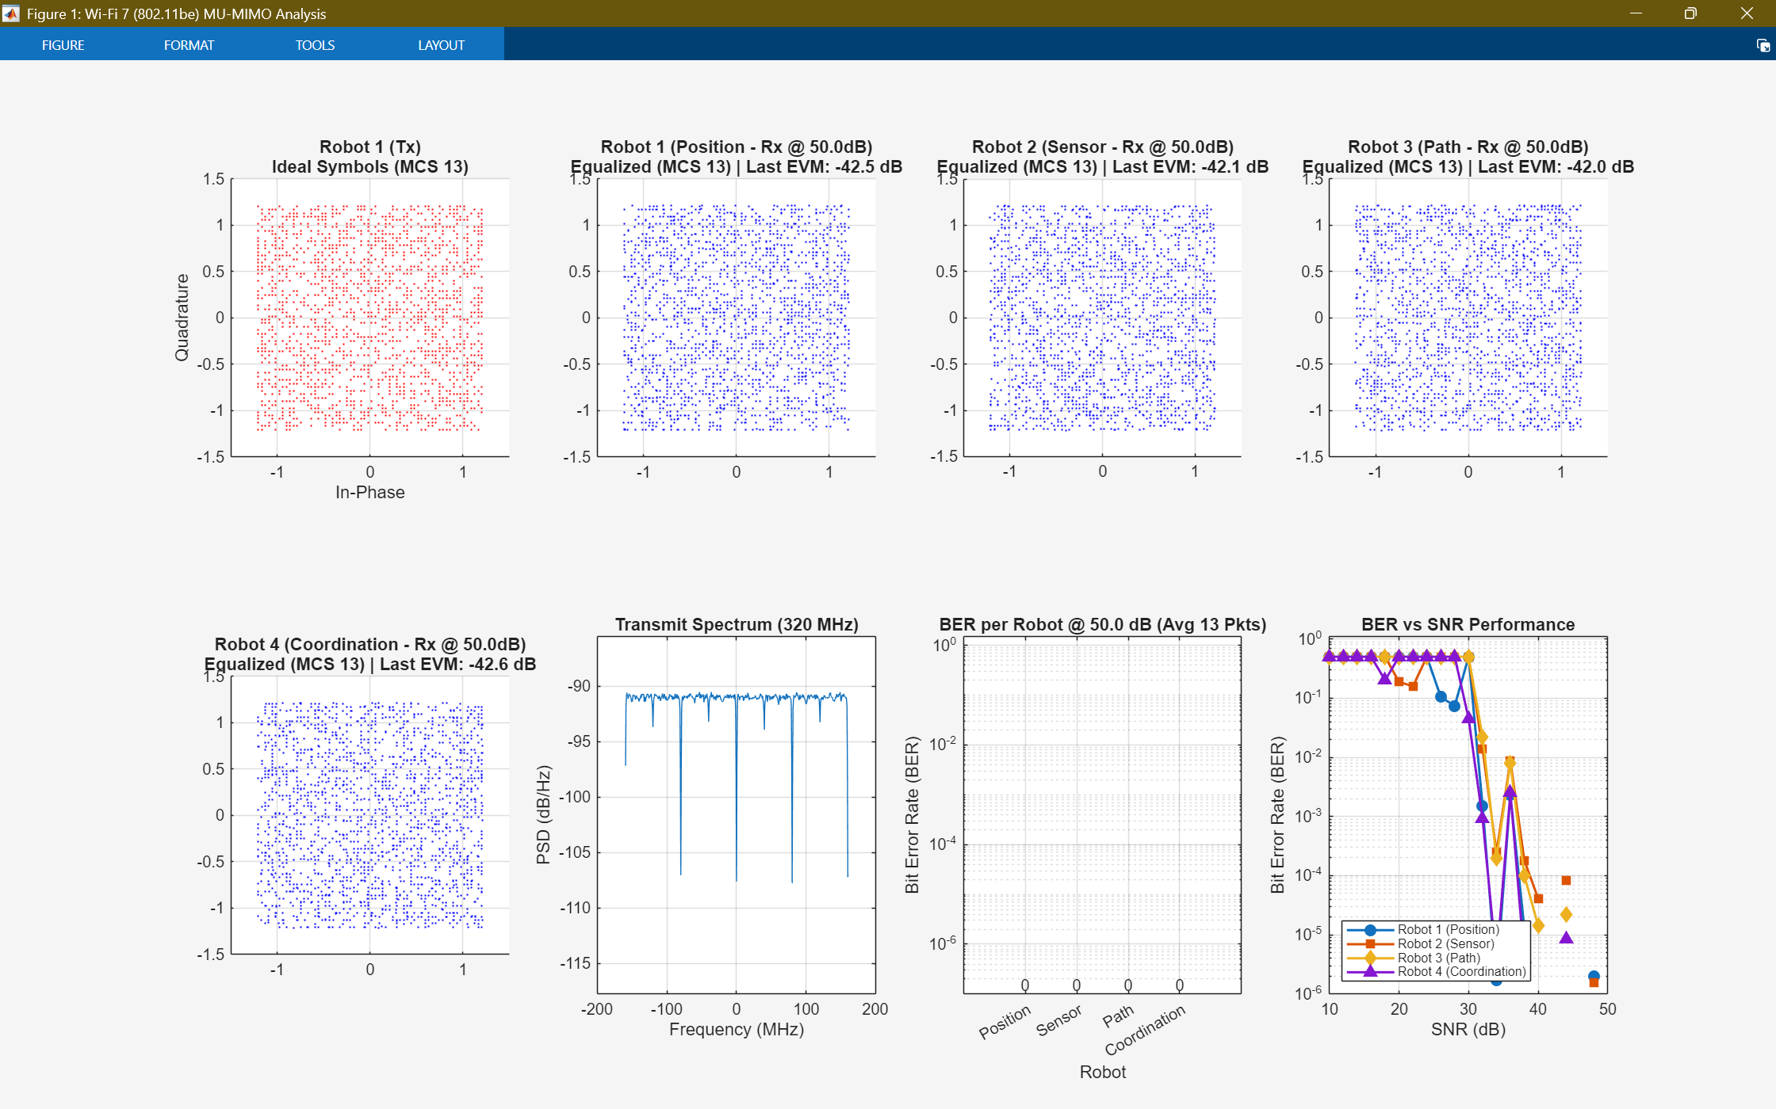  Fig. 7(a) |   Fig. 7(b)
  Fig. 7(c) |   Fig. 7(d)
  Fig. 7(e) |   Fig. 7(f)
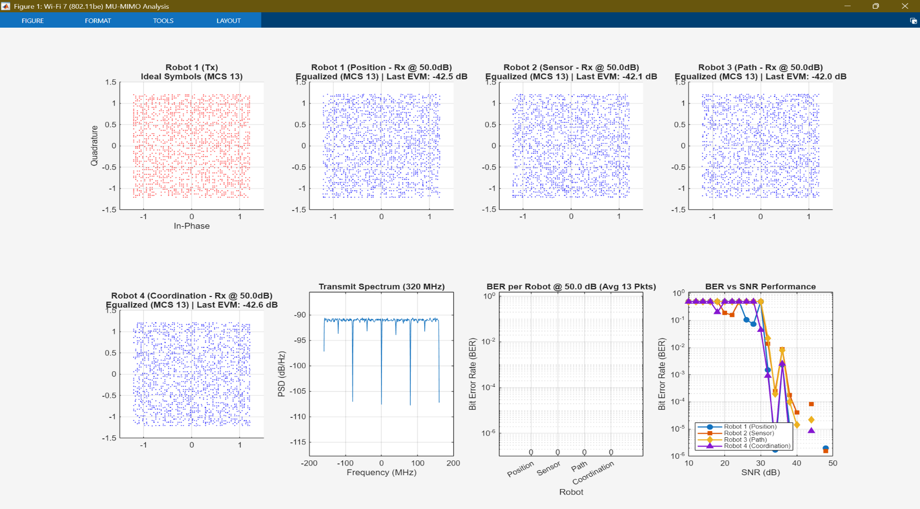  Fig. 7(g) |   Fig. 7(h)
Fig. 7. Composite simulation results. (a) Ideal transmitted 4096-QAM constellation (MCS 13). (b) Power Spectral Density (PSD) of the transmitted 320 MHz signal (c) Received equalized constellation for Robot 1 at 50 dB SNR (EVM: -42.5 dB). (d) Received equalized constellation for Robot 2 at 50 dB SNR (EVM: -42.1 dB). (e) Received equalized constellation for Robot 3 at 50 dB SNR (EVM: -42.0 dB). (f) Received equalized constellation for Robot 4 at 50 dB SNR (EVM: -42.6 dB). (g) Per-robot Bit Error Rate (BER) at 50 dB SNR, showing error-free (0.0) performance. (h) Individual BER vs. SNR performance for each of the four robots.
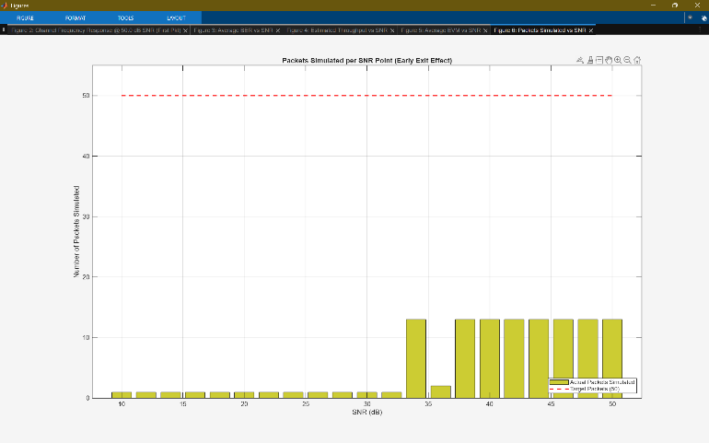
Fig 8. Number of packets simulated per SNR point, demonstrating the effect of the early exit criteria (minErrors=100, minBits=1e7). The simulation runs longer at higher SNRs where error rates are lower.

5 Conclusion and Future Work
5.1 Conclusion
This paper examined the physical layer operation of an IEEE 802.11be (Wi-Fi 7) MU-MIMO system to support downlink communication in one of the swarm robotics scenarios in real-time. In the simulation of MATLAB, we tested a 4 × 8 MU-MIMO system using the maximum modulation scheme (MCS 13, 4096-QAM) at 320 MHz channel conditions with puts under strenuous and non-line of sight. What was found is that, though Wi-Fi 7 can reach its theoretical maximum and aggregate throughput of about 11.528 Gbps in this 4-stream setup it required high Signal-to-Noise Ratios (SNR > 40 dB) in the simulated NLOS environment to do so. The high-order modulation was unreliable below 32 dB SNR (BER 200). The high SNR decoding despite the fading channel of such a degree highlights the huge advantage that the diversity of the receivers which is granted by the 8-antenna robot system (an effective system of 8 x 1 per stream) offers. These findings indicate that although Wi-Fi 7 has a high bandwidth potential when used in cases that are data intensive swarm applications, the use of the highest MCS modes such as MCS 13 requires both favorable channel conditions or short ranges. Considerable experimentally in practical applications with dynamic and unpredictable environments as is the case with swarm robotics, robot link adaptation techniques that dynamically choose higher order MCS values will be essential in facilitating reliable communication, but at reduced peak data rates.
  - Future Work
Although the current study has put in place a foundation of the physical layer (PHY) performance of the Wi-Fi 7 in swarm robots, future directions of this field would broaden in two major directions. The first one is to undertake a dynamic and cross-layer comparison to integrate Medium Access Control (MAC) protocols and PHY layer data and, therefore, define the effect of network contention, transmission time, and end-to-end delay in large-scale swarms; simulation of robotic mobility is necessary to consider the influence of Doppler spread on channel estimation. Second, to achieve reliability in hostile or defensive conditions verification needs to go beyond the internal Additive White Gaussian Noise (AWGN) model to more complicated external conditions, including co-channel interference with external sources, and active jamming models.
6 References
[1] R. Groß, M. Bonani, F. Mondada, and M. Dorigo, "Signalling and social learning in swarms of robots," Philosophical Transactions of the Royal Society A: Mathematical, Physical and Engineering Sciences, vol. 382, no. 2283, 2024. Accessed: Oct. 29, 2025. [Online]. Available: https://royalsocietypublishing.org/doi/10.1098/rsta.2024.0148
[2] L. Bayindir and E. Şimşek, "Swarm Robotics: A Survey," Pattern Recognition and Artificial Intelligence, vol. 35, no. 06, p. 2150013, 2021. Accessed: Oct. 29, 2025. [Online]. Available: http://manu46.magtech.com.cn/Jweb_prai/EN/abstract/abstract10297.shtml
[3] S. U. Khan, S. A. G. Rizvi, and M. A. Khan, "Survey on Security Challenges for Swarm Robotics," arXiv preprint arXiv: [Number Placeholder], [Date Placeholder]. Accessed: Oct. 29, 2025. [Online]. Available: https://scispace.com/pdf/survey-on-security-challenges-for-swarm-robotics-3ir9jw3ar1.pdf (Assuming arXiv)
[4] L. Kolling, A. Kleiner, M. Lewis, and K. Sycara, "Human Interaction With Robot Swarms: A Survey," IEEE Transactions on Human-Machine Systems, vol. 46, no. 1, pp. 9-26, Feb. 2016. Accessed: Oct. 29, 2025. [Online]. Available: https://www.researchgate.net/publication/283775695_Human_Interaction_With_Robot_Swarms_A_Survey
[5] S. Chung, A. A. Paranjape, P. Dames, S. Shen, and V. Kumar, "A Survey on Aerial Swarm Robotics," IEEE Transactions on Robotics (TRO), vol. 34, no. 4, pp. 837-855, Aug. 2018. Accessed: Oct. 29, 2025. [Online]. Available: https://sites.temple.edu/pdames/files/2019/03/ChungEtAlTRO2018.pdf
[6] M. F. M. A. B. Abdullah, M. A. B. A. As’arry, M. K. B. M. Noh, and M. H. B. Othman, "A Critical Review of Communications in Multi-robot Systems," Sensors (Basel), vol. 22, no. 22, p. 8868, Nov. 2022. Accessed: Oct. 29, 2025. [Online]. Available: https://pmc.ncbi.nlm.nih.gov/articles/PMC9666305/
[7] M. Coppola, D. P. K. Le, F. Pasquale, G. Pesce, M. Tufano, and S. P. Romano, "Recent Advances in Swarm Robotics Coordination: Communication and Consensus," Applied Sciences, vol. 12, no. 21, p. 11116, Oct. 2022. Accessed: Oct. 29, 2025. [Online]. Available: https://www.mdpi.com/2076-3417/12/21/11116
[8] M. H. Mahfoud, A. Younes, C. Francis, and R. Zantout, "Swarm SLAM: Challenges and Perspectives," Frontiers in Robotics and AI, vol. 8, p. 618268, Mar. 2021. Accessed: Oct. 29, 2025. [Online]. Available: https://www.frontiersin.org/journals/robotics-and-ai/articles/10.3389/frobt.2021.618268/full
[9] A. Farinelli, G. Grisetti, L. Iocchi, S. Loianno, and D. Nardi, "Socially Inspired Communication in Swarm Robotics," in Proc. AAMAS Workshop on Adaptive and Learning Agents, 2019. Accessed: Oct. 29, 2025. [Online]. Available: https://www-users.cse.umn.edu/~gini/publications/papers/White2019ARMS.pdf
[10] M. S. U. Khan, A. K. Kasi, and S. H. Khattak, "Advanced Communication Protocols For Swarm Robotics: A Survey," in Proc. 7th Int. Conf. on Informatics and Systems (INFOS), Mar. 2010. Accessed: Oct. 29, 2025. [Online]. Available: https://www.researchgate.net/publication/280112433_Advanced_Communication_Protocols_For_Swarm_Robotics_A_Survey
[11] S. M. Kia, J. R. T. López, N. C. Martins, and J. P. Hespanha, "Adaptive Communication in Multi-Robot Systems Using Directionality of Signal Strength," The International Journal of Robotics Research (IJRR), vol. 34, no. 7, pp. 917-938, Jun. 2015. Accessed: Oct. 29, 2025. [Online]. Available: https://react.seas.harvard.edu/files/react/files/pub_ijrr_2014_final.pdf
[12] M. B. Egerstedt, Y. Wardi, and A. F. Taha, "Communication Complexity of Multi-Robot Systems," [Publication Placeholder, e.g., Conference Name], [Date Placeholder]. Accessed: Oct. 29, 2025. [Online]. Available: https://www.seas.ucla.edu/coopcontrol/papers/mvcc.pdf
[13] T. de Groot, N. J. J. M. K. van der Wouw, and N. H. D. van de Wouw, "Epistemic planning for multi-robot systems in communication-restricted environments," Frontiers in Robotics and AI, vol. 10, p. 1149439, Apr. 2023. Accessed: Oct. 29, 2025. [Online]. Available: https://www.frontiersin.org/journals/robotics-and-ai/articles/10.3389/frobt.2023.1149439/full
[14] M. Khalfi, S. El Adel, I. Boumhidi, and F. El Mounchid, "Exploring the Potential of Wi-Fi in Industrial Environments: A Comparative Analysis," Signals, vol. 6, no. 2, p. 40, May 2025. Accessed: Oct. 29, 2025. [Online]. Available: https://www.mdpi.com/2673-4001/6/2/40
[15] V. Sharma, N. Singh, and R. Kumar, "Inter-communication between Swarm-Bots," International Journal of Advanced Research, Ideas and Innovations in Technology (IJARIIT), vol. 5, no. 3, pp. [Pages Placeholder], 2019. Accessed: Oct. 29, 2025. [Online]. Available: https://www.ijariit.com/manuscripts/v5i3/V5I3-1629.pdf
[16] Y. Liu and X. Wang, "The study of ZigBee technology's application in swarm robotics system," in Proc. IEEE Int. Conf. on Mechatronics and Automation (ICMA), Aug. 2012, pp. 1957-1961. Accessed: Oct. 29, 2025. [Online]. Available: https://www.researchgate.net/publication/241190644_The_study_of_ZigBee_technology's_application_in_swarm_robotics_system
[17] IEEE Std 802.11be™-2024, IEEE Standard for Information technology—Telecommunications and information exchange between systems Local and metropolitan area networks—Specific requirements Part 11: Wireless LAN Medium Access Control (MAC) and Physical Layer (PHY) Specifications Amendment 8: Enhancements for Extremely High Throughput (EHT), May 2024. Accessed: Oct. 29, 2025. [Online]. Available: https://standards.ieee.org/ieee/802.11be/7516/
[18] E. Khorov, I. Levitsky, and I. F. Akyildiz, "Time-Sensitive Networking in IEEE 802.11be: On the Way to Low-Latency WiFi 7," Sensors (Basel), vol. 21, no. 15, p. 4954, Jul. 2021. Accessed: Oct. 29, 2025. [Online]. Available: https://www.mdpi.com/1424-8220/21/15/4954
[19] MathWorks, "Overview of Wi-Fi 7 (IEEE 802.11be)," MATLAB WLAN Toolbox Documentation. Accessed: Oct. 29, 2025. [Online]. Available: https://www.mathworks.com/help/wlan/ug/overview-of-wifi-7-or-ieee-802-11-be.html
[20] B. Chen et al., "IEEE 802.11be Wi-Fi 7: Feature Summary and Performance Evaluation," arXiv preprint arXiv:2309.15951, Oct. 2023. Accessed: Oct. 29, 2025. [Online]. Available: https://arxiv.org/html/2309.15951v3
[21] B. Chen and S. Chen, "Overview and Performance Evaluation of Wi-Fi 7," Journal of Communications and Information Networks, vol. 8, no. 1, pp. 1-18, Mar. 2023. Accessed: Oct. 29, 2025. [Online]. Available: https://www.semanticscholar.org/paper/Overview-and-Performance-Evaluation-of-Wi-Fi-7-Chen-Chen/2193b2a07b7cb9921de0b69ee00cee12eeafa35c
[22] M. Carrascosa, G. Geraci, E. Knightly, and B. Bellalta, "An Experimental Study of Latency for IEEE 802.11be Multi-link Operation," in Proc. IEEE INFOCOM 2023 - IEEE Conference on Computer Communications Workshops (INFOCOM WKSHPS), May 2023, pp. 1-6. Accessed: Oct. 29, 2025. [Online]. Available: https://www.semanticscholar.org/paper/An-Experimental-Study-of-Latency-for-IEEE-802.11be-Carrascosa-Geraci/f13a17c91fc841bdb122ba65359a599a942a712f
[23] MathWorks, "802.11be (Wi-Fi 7) End-to-End Simulation with MU-MIMO," MATLAB WLAN Toolbox Documentation. Accessed: Oct. 29, 2025. [Online]. Available: https://www.mathworks.com/help/wlan/802.11be-end-to-end-simulation.html
[24] M. J. Orbeta and A. A. Sese, "Experimental evaluation of transmission link selection in IEEE 802.11be multi-link operation," [Publication Placeholder, e.g., Conference Name], Jul. 2023. Accessed: Oct. 29, 2025. [Online]. Available: https://www.researchgate.net/publication/372239417_Experimental_evaluation_of_transmission_link_selection_in_IEEE_80211be_multi-link_operation
7 Author Biographies


Harsh Singhal is being undertaking the B.Tech. degree in Electronics and Communication Engineering degree in Vellore Institute of Technology in Chennai, India. He is interested in the research on wireless communication systems, digital signal processing, and the use of future-generation protocols such as Wi-Fi 7 to manage robotic systems.


Niket Suthar is in the B.Tech. programme in Electronics and Communication Engineering, currently undertaking the course of study at Vellore Institute of Technology which is located in Chennai, India. He has interests in MIMO systems, swarm robotics and physical layer simulation of new wireless standards.


Shivam Yadav is presently undertaking the B.Tech. degree in Electronics and Communication Engineering in Vellore Institute of Technology, Chennai, India. His scholarly skills lie in the area of digital communication systems, modeling radio channels, and the behavior of high throughput wireless networks.


Tarang Gupta is presently undergoing B.Tech. degree in Electronics and Communication Engineering in Vellore Institute of technology, Chennai, India. His research areas are next generation Wi-Fi technologies, embedded systems based on real-time application and the Internet of Things (IoT) technology.


Vetrivelan Pandu is an Indian Professor (in the School of Electronics Engineering) and the Controller of Examinations (COE) at the Vellore Institute of Technology (VIT), Chennai. He is also a member of the Member of IoT and 5G working committee with the Department of Telecommunications, Ministry of communications, Government of India. He has published many chapters in books, and more than 40 papers that have been indexed in the Scopus. He has interests in 5G/6G Wireless Networks, Internet of Things (IoT), AI and Data Analytics, and Adhoc and Sensor Networks.

